Eco friendly candles
Each candle is unique (see reverse for some examples) because it is hand-made and contained in recycled tin cans, jars, shells etc. They come scented with 100% pure essential oils and also come unscented. They aim to capture the magic of the Caithness area, using local resources e.g. shells, sea glass and pine cones; and are named after local features and locations. The most sustainable and environmentally friendly wax is used i.e. coconut and rapeseed. This luxurious wax carries the scent well, has a slow burn time, is smokeless and soot free. The cotton wicks are also soot free, burning clean and even.

“The Flows”
Hailed as “one of the world’s last wild places”, The Flow Country stretches across Caithness and Sutherland and is the largest peatland in Europe. The candle is infused with Ylang ylang and Patchouli essential oils so it may evoke balance, having an earthy as well as high and light aroma.

“Murkle Bay”
Murkle Bay lies just east of Thurso and is a magical, uplifting whilst peaceful place with beautiful views and lots of interesting features on the beach itself. The shells are used to decorate the candle and, if you are very lucky you may find a Groatie Buckie embedded in yours (Cowrie shell), said to bring good fortune and wellbeing. The candle is infused with Lemon and Rosemary essential oils so it wakes up the senses and has a refreshing aroma.

“Aurora”
Caithness is a “hot spot” area to see the Aurora Borealis – the Northern Lights. The candle is infused with Lavender and Myrrh essential oils so it may evoke a sense of escape, calm and intrigue.

“Dunnet Forest”
Dunnet Forest overlooks the beautiful Dunnet Bay, east of TMurkle Bay and five miles from Dunnet Head which is the most northerly point of mainland Scotland. The candle is decorated with pine cones collected from the forest floor. It is infused with Scots Pine and Bergamot essential oils so it has a woody yet floral aroma with a hint of spice to refresh, uplift and clear the mind.

“Northern Light”
An unscented candle giving off a pure light from the luxurious eco wax, holding in mind the open spaces and endless skies of Caithness.

Hand made by Jane at www.aurora-bb.co.uk
MURKLE BAY MURKLE BAY
THE FLOWS AURORA
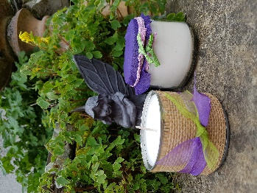
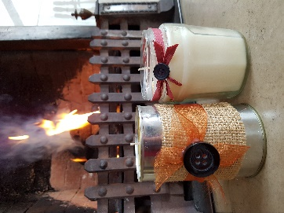
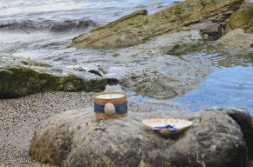
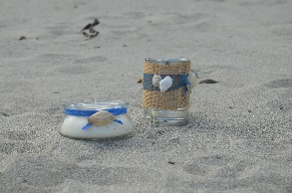
DUNNET FOREST NORTHERN LIGHT
